**Project Abstract**

PetInsights is a (flexible) application that bridges the gap between people seeking to adopt and animal shelters.

**Facts about animal shelter statistics;** [**https://www.aspca.org/animal-homelessness/shelter-intake-and-surrender/pet-statistics**](https://www.aspca.org/animal-homelessness/shelter-intake-and-surrender/pet-statistics)

**Flexible – to say it’s available on desktop and mobile**

**Key Terms:**

* Issues faced :
  + Many shelters struggle with returned animals due to the owner being surprised by the animal behavior. 10% of animals tend to be returned (don’t have a fact check for this though)
* Adopting is a risky process – often times (10%) animals are returned from the owners due to unexpected behavior that didn’t fit with family dynamics.
* Bridge the gap between the people looking to adopt and animals shelters.
* Crowd sources
* Help adopters find a better fit for them, to reduce returned pets due to unexpected behavior.
* Help animal shelters meet their needs by recruiting volunteers and asking for donations.

volunteers and getting the donation items they need. Hey there hello Regarding the adoption-seekers, often we see cases where people return the animals they’ve adopted due to the pet being different than what they expected. For example, someone who wanted a calm dog for their kids returns a newly adopted one that ended up being highly energetic. Our application will tackle this issue by offering crowd-sourced feedbacks on the sheltered animals during interactions. The feedback may come from volunteers who walk the dogs or socialize with the cats, or from visitors who got the chance to interact with an animal

^^ example of 100 words

**Requirements:**

1. Project Title
2. Team Members
3. Faculty Advisor
4. Project Background
   1. What motivated you to do the project
5. Problem Statement
   1. What is the purpose of your project
6. Inadequacy of Current Solutions
   1. *Buggy + aren't as seamless as they could be*
   2. *Would need more research !!*
7. Background Skills / Interests Related to the Project
   1. List out our interests collectively, and I guess skills too
   2. **If we want to separate by member, we can do that too**
8. Approach to Problem
   1. Functionality?
   2. *Maybe can say how we'll use a similar layout that people are already familiar with (Yelp)*

Generic Project Description (for proposal to Teresa Hamad):

We would like to create a mobile application or a web-development application supporting local animal shelters (with the goal to span out nationally). We would like to help both the adoption-seekers in finding the right pet for them, along with the animal shelters themselves in recruiting volunteers and getting the donation items they need.

Regarding the adoption-seekers, often we see cases where people return the animals they’ve adopted due to the pet being different than what they expected. For example, someone who wanted a calm dog for their kids returns a newly adopted one that ended up being highly energetic. Our application will tackle this issue by offering crowd-sourced feedbacks on the sheltered animals during interactions. The feedback may come from volunteers who walk the dogs or socialize with the cats, or from visitors who got the chance to interact with an animal they thought they wanted to adopt.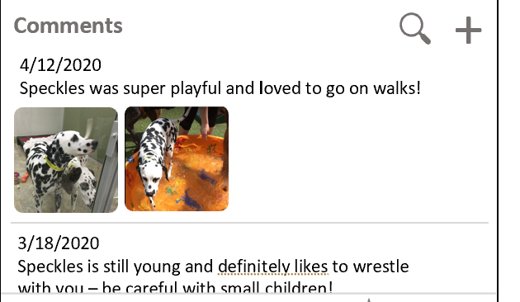

Screenshot from demo screen:

Regarding the animal shelters, I can see our application helping them in terms of recruiting volunteers and collecting donations. Shelters will be able to submit the items they are in need of, and users of the app will be able to search which shelters need what. When the shelters have received enough of a certain item, they can update the application and inform users to direct their items elsewhere.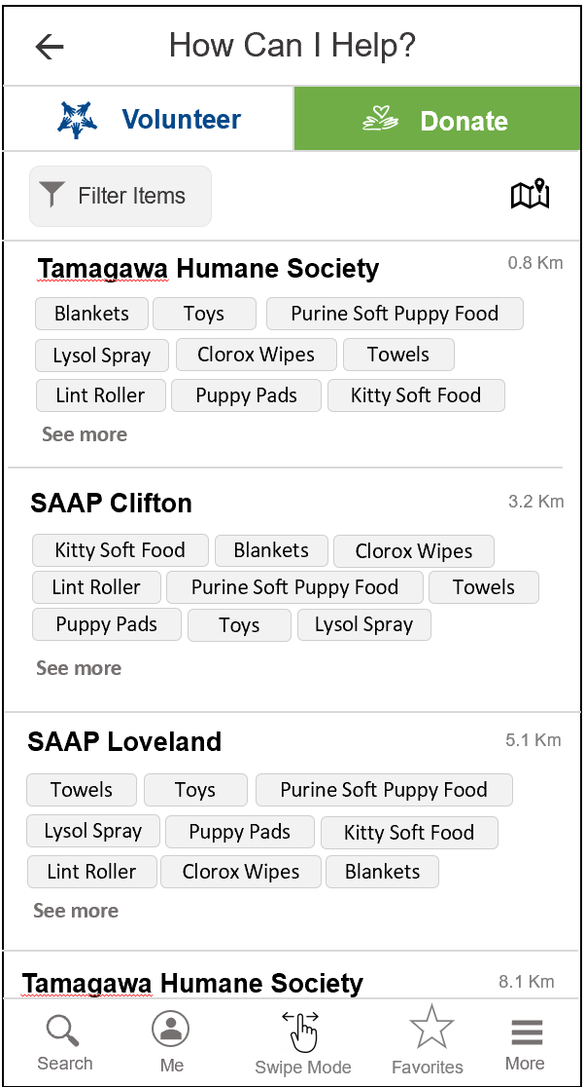

There will be two main views of the application.

1. User View: Users can search for an animal that matches their needs and give feedback on the ones they got the chance to interact with.
2. Shelters/Volunteers View: Representatives of the shelter or volunteers with access can update their information and review the feedback submitted on the animals.

Our application would create an online, easy way to search for pets remotely (especially in the era of Covid-19) and help organizations in need. We plan to continue supporting and improving this application even beyond senior design.

**PetInsight Project Proposal**

We would like to create a mobile application or a web-development application supporting local animal shelters (with the long-term goal to span out nationally). We would like to help both the adoption-seekers in finding the right pet for them, along with the animal shelters themselves in recruiting volunteers and getting the donation items they need.

Regarding the adoption-seekers, often we see cases where people return the animals they’ve adopted due to the pet being different than what they expected. For example, someone who wanted a calm dog for their kids returns a newly adopted one that ended up being highly energetic. Our application will tackle this issue by offering crowd-sourced feedbacks on the sheltered animals during interactions. The feedback may come from volunteers who walk the dogs or socialize with the cats, or from visitors who got the chance to interact with an animal they thought they wanted to adopt.

The below is an example where visitors have comments that this specific dog, Speckles, is playful, energetic, and not suitable for small children. Screenshot is taken from a demo I designed in Word.



Regarding the animal shelters, I can see our application helping them in terms of recruiting volunteers and collecting donations. Shelters will be able to submit the items they are in need of, and users of the app will be able to search which shelters need what. When the shelters have received enough of a certain item, they can update the application and inform users to direct their items elsewhere.



There will be two main views of the application.

1. User View: Users can search for an animal that matches their needs and give feedback on the ones they got the chance to interact with.
2. Shelters/Volunteers View: Representatives of the shelter or volunteers with access can update their information and review the feedback submitted on the animals.

Some additional technical details include:

* Account creation for users to help keep track of sheltered animals they’re interested in, with the possibility of notifying them when there’s been an update.
* Database storage of comments and images of sheltered animals

Our application would create an online, easy way to search for pets remotely (especially in the era of Covid-19) and help organizations in need. We plan to continue supporting and improving this application even beyond senior design.